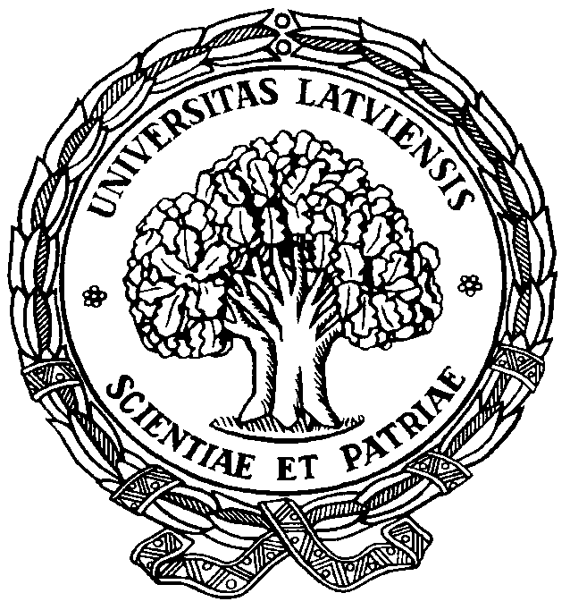

UNIVERSITY OF LATVIA

Faculty of Humanities
Department of Latvian and Baltic Studies
Department of Baltic Linguistics

59th

Conference of the
Arturs Ozols Day

Rīga
April 19, 2024

You are kindly invited to participate in the 59th Conference of the
Arturs Ozols Day

DIVERSITY AND RULES OF THE ELEMENTS OF THE BALTIC LANGUAGE SYSTEM

The conference is dedicated to the research of the elements of the Baltic language and dialect system in both synchronic and diachronic aspects across various levels of the language system. Research objects and methods from early texts and onomastics to sociolinguistics and computer linguistics will be explored.

This year marks the 380th anniversary of the publication of the first Latvian grammar – J. G. Rehehusen's "Manuductio ad linguam lettonicam" (1644).

The Conference will take place on

April 19, 2024

Working languages: Latvian,
Lithuanian,
English, German.
Please submit your application
and an abstract (ca 250–300 words)
before April 1, 2024

Registration fee: 10 EUR

You may wish to publish your paper in the journal Baltu filoloģija, which is an internationally reviewed periodical

Our address:

Department of Baltic Linguistics
Faculty of Humanities,
University of Latvia,
Visvalža iela 4a,
Rīga LV – 1050
Latvia

e-mail:
peteris.vanags@lu.lv
lidija.leikuma@lu.lv
edmundas.trumpa@lu.lv
Application form

First name, last name: _____________
________________________________

Title of paper: ___________________
________________________________________________________________________________________________________________________________

Address, phone, e-mail: ____________
________________________________________________________________________________________________________________________________________________________________________________________________

Affiliation, Position, Title/Degree: ___ ________________________________
________________________________________________________________
.

